Newport Junior
Football League
NEWSLETTER NOVEMBER2023

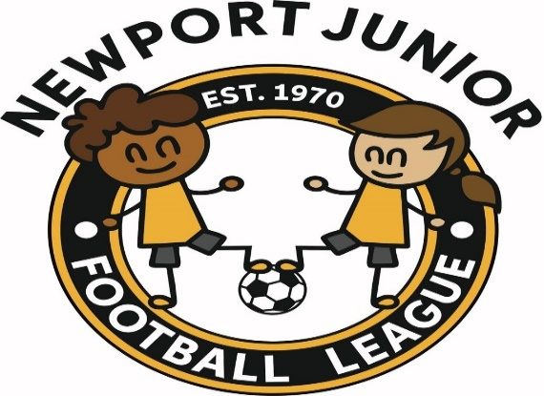

CONDUCT & BEHAVIOUR
It is very sad that I must start this Newsletter to talk about the disgraceful conduct & behaviour that is happening week in week out at our football matches.

The disrespect shown to referees and club referees is an utter disgrace. These people are doing this job so the children of Newport can play football. A lot of this disrespect is from coaches and parents on the side line.

League officers have been out to many games since the start of the season including Monmouthshire League games and have had to witness this terrible behaviour.

I can only say that this must stop NOW. We as a league are going to take a hard stance with offenders. As League Officers we have had to attend many meetings regarding this issue and have made the following decisions with the approval of the Gwent County FA.

Mini teams and players may face suspensions from all football activities if found guilty of any offences. Parents and spectators may also face the same suspension. You might say we cannot stop people from entering a public park. Quite right, but they will have to stay well away from the football game. If caught it is the club that may face financial penalties.

Competitive teams may face a deduction in points and heavy fines if they are found guilty of any misconduct at games.

BEHIND THE LINE
Behind the line is a rule. After going to many games already this season it seems most clubs are not adhering to this rule. This is the final warning from now on fines will be sent to all clubs not adhering to this rule.

When playing at the 3G players and coaches only are allowed in the playing area. All spectators’ parents must stay behind the barrier. At Cefn Wood 3G however no spectators are allowed inside of the cage. The same applies to the Welsh School 3G pitch.

Also, a message to coaches when at games. You must stay behind the side line. So many times, at matches coaches are halfway across the pitch. You must not enter the field of play. The referee has the right to send you off. Something that stops now.

ID CARDS
You might remember a few years ago the FAW run this system. Talks are in place at present to look at getting this reintroduced. By using the ID badges, it would make managers/coaches more recognisable to all at games.

MINI TEAMS
The cut off date to enter or take out mini teams from January to April 2024 is the 4th December 2023. Please send these requests to Dave Bird. After the cut off date you will not be able to enter anymore teams unless there is a spare in that age group.

SLIDING TACKLES
Sliding tackles is something that we do not want to see in football. But recently whilst out watching the mini teams it seems to be the norm. Coaches, please instruct your players accordingly, this is very dangerous if players studs catch a players legs and could cause untold harm to players.

CONFIRMING TEAM ON COMET
You would have all received this information from Dave a few days ago. Anyone did not receive this information please contact me.

CHANGE OF EMAIL ADDRESS
I have changed my email address. So, from June 2023 I shall be using the following email address for all football related issues. My new email address will be NJFLSec@gmail.com

FAW WEB SITE
Please check out the FAW – Clwb Cymru website. An excellent site for all football clubs.

WEB SITE
Our new website is under construction we hope to have this up and running come the new year.

Secretaries, please ensure that this Newsletter is distributed to all at your club including committee members

Managers – please show these Newsletters to your parents or direct them to our website

Many thanks to the following for sponsorship of our league

The Awards Company for all your trophies
www.theawardscompany.couk 07770773323

S J Parry Decorators & Maintenance Ltd
www.sjparry.com 0797644357

